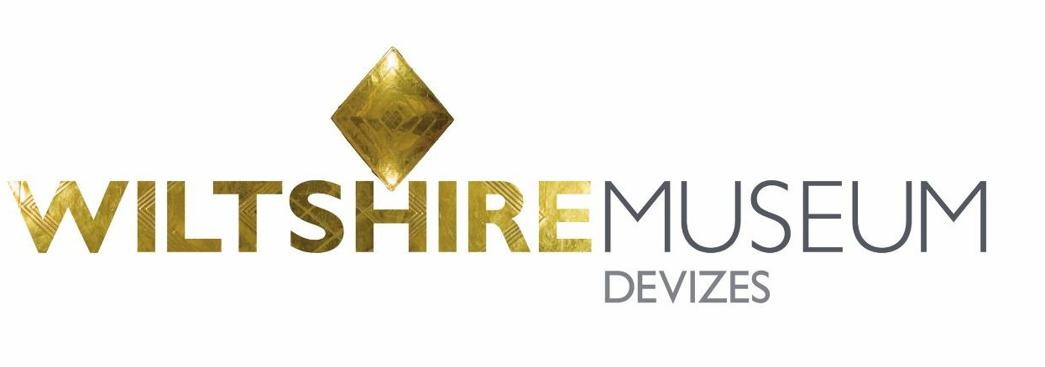

Volunteer Role Description – Exhibition Steward Volunteer
We are equal opportunities employers, which means that we are committed to providing equality of opportunity in employment to all persons.

Role Title | Exhibition Steward Volunteer
Purpose of Role | To be part of a team of volunteers responsible for enhancing the  visitor experience to Wiltshire Museum during our 2020 summer/autumn exhibitions.
Main Activities and tasks | - To welcome visitors to the exhibition and direct them around the space  - To engage with visitors and answer questions about the exhibition and Museum  - To be vigilant at all times with regard to safety and security with the collection and visitors  - To ensure the exhibition space remains clean and tidy  - To assist with the flow of visitors and support the front desk during particularly busy periods  - To undertake visitor surveys on behalf of the Museum  - To understand and comply with the fire evacuation procedure
Skills needed | - An interest in Wiltshire Museum and our exhibition programme  - A willingness to learn about the contents of the exhibition and the Museum’s collections  - Enjoy working with the public  - Good communication skills  - Polite and approachable  - Reliable
Training | Training will include:  - Tour of the Museum  - Induction including health and safety  - Briefings and training on exhibition subject  - Visitor services and audience survey training  - Ongoing support from the staff team
Time commitment | A regular weekly or fortnightly shift of 1 hour and 45 minutes (or a double shift of 3 hours and 30 minutes).  This role will involve a trial period of 1 month to ensure that it is the right role for you.

